30-08-2026

19. Prolog Program for a Database with Name and DOB

Aim
To create a Prolog database containing person's name and date of birth and retrieve the details.

Program
person(aseem, 2004, 10, 15).
person(arun, 2003, 5, 20).
person(kumar, 2005, 8, 12).
person(priya, 2004, 12, 25).

find_dob(Name, Year, Month, Day) :-
person(Name, Year, Month, Day).

Output

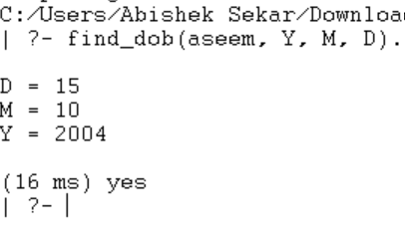

RESULT
Thus, the Prolog program was successfully executed to store and retrieve the name and date of birth.

